**Analytic Query 1 (AQ1):**

AQ1 extends BQ1 with a window comparison involving the cumulative sum of the order amount, partitioned for each combination of location name and year. Note the analytic function specification for the CumSumAmt computed column.

-- Cumulative amount ordered by location, year, and month

|  |
| --- |
| SELECT Location_Name  ,Time_Year  ,Time_Month  ,SUM(QUANTITY_ORDERED * Unit_Price) AS SumJobAmt  ,SUM(SUM(QUANTITY_ORDERED * Unit_Price)) OVER (  PARTITION BY Location_Name  ,Time_Year ORDER BY Time_Month ROWS UNBOUNDED PRECEDING  ) AS CumSumAmt  FROM W_JOB_F  ,W_Location_D  ,W_TIME_D  WHERE W_Location_D.Location_ID = W_Job_F.Location_Id  AND W_JOB_F.CONTRACT_DATE = W_TIME_D.Time_ID  GROUP BY Location_Name  ,Time_Year  ,Time_Month; |

**Screenshot:**

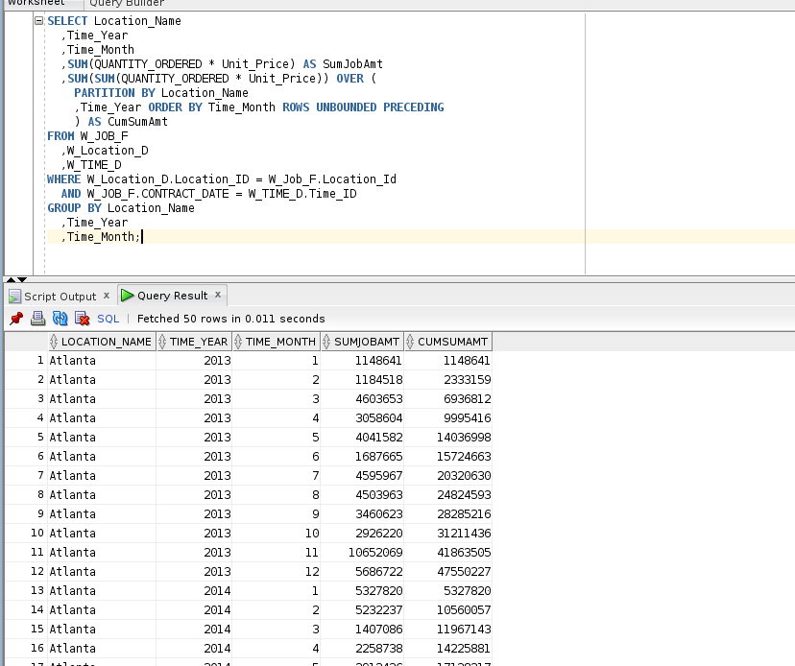

**Analytic query 2 (AQ2):**

AQ2 extends BQ1 with a window comparison involving the moving average of the average order amount, partitioned by location name with criteria of year and month. The moving average is calculated over the current row and 11 preceding rows. In the SELECT statement, note the analytic function specification for the MovAvgAmtOrdered computed column.

-- Moving average over current row and 11 preceding rows of average amount

-- Partitioned by location name

-- Ordering criteria by year and month

|  |
| --- |
| SELECT Location_Name  ,Time_Year  ,Time_Month  ,AVG(QUANTITY_ORDERED * Unit_Price) AS AvgJobAmount  ,AVG(AVG(QUANTITY_ORDERED * Unit_Price)) OVER (  PARTITION BY Location_Name ORDER BY Time_Year  ,Time_Month ROWS BETWEEN 11 PRECEDING  AND CURRENT ROW  ) AS MovAvgAmtOrdered  FROM W_JOB_F  ,W_Location_D  ,W_TIME_D  WHERE W_Location_D.Location_ID = W_Job_F.Location_Id  AND W_JOB_F.CONTRACT_DATE = W_TIME_D.Time_ID  GROUP BY Location_Name  ,Time_Year  ,Time_Month; |

**Screenshot:**

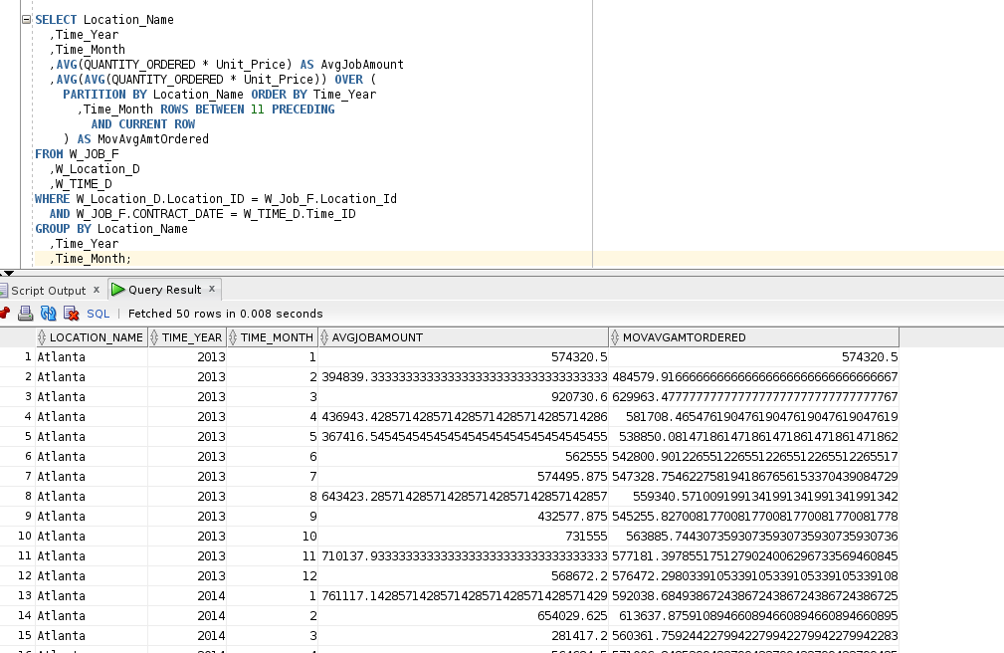

**Analytic query 3 (AQ3):**

AQ3 extends BQ2 and BQ3 with ranking of locations by sum of profit. Ranking starts over for each contract year. Two SELECT statement solutions are shown. The first and simpler solution uses views containing SELECT statements for BQ2 and BQ3. The WHERE clause contains a join condition on Job_Id combining the views for BQ2 and BQ3. The second and more complex solution uses base queries for BQ2 and BQ3 in the FROM clause instead of views. The WHERE clause contains a join condition on Job_Id combining the nested queries for BQ2 and BQ3. In both solutions, profit is computed AS SumInvoiceAmt – TotalCosts.

-- Rank locations by descending sum of annual profit

-- Extends BQ2 and BQ3

-- Using views for location revenue and location cost summaries

|  |
| --- |
| SELECT X1.Location_Name  ,X1.Time_Year  ,SUM(SumInvoiceAmt - TotalCosts) AS SumLocProfit  ,RANK() OVER (  PARTITION BY X1.Time_Year ORDER BY (SUM(SumInvoiceAmt - TotalCosts)) DESC  ) AS RankProfitSum  FROM LocCostSummary X1  ,LocRevenueSummary X2  WHERE X1.Job_Id = X2.Job_Id  GROUP BY X1.Location_Name  ,X1.Time_Year;  -- Using base queries for location revenue and location cost summaries  SELECT X1.Location_Name  ,X1.Time_Year  ,SUM(SumInvoiceAmt - TotalCosts) AS SumLocProfit  ,RANK() OVER (  PARTITION BY X1.Time_Year ORDER BY (SUM(SumInvoiceAmt - TotalCosts)) DESC  ) AS RankProfitSum  FROM (  SELECT W_Sub_Job_F.Job_Id  ,W_Location_D.LOCATION_ID  ,W_LOCATION_D.LOCATION_NAME  ,W_TIME_D.TIME_YEAR  ,W_TIME_D.TIME_MONTH  ,SUM(Invoice_Quantity) AS SumInvoiceQty  ,SUM(Invoice_Amount) AS SumInvoiceAmt  FROM W_Job_Shipment_F  ,W_Sub_Job_F  ,W_Location_D  ,W_Time_D  ,W_InvoiceLine_F  ,W_Job_F  WHERE W_Sub_Job_F.Sub_Job_Id = W_Job_Shipment_F.Sub_Job_Id  AND W_Job_Shipment_F.Invoice_Id = W_InvoiceLine_F.Invoice_Id  AND W_Time_D.Time_Id = Contract_Date  AND W_Location_D.Location_Id = W_InvoiceLine_F.Location_Id  AND W_Job_F.Job_Id = W_Sub_Job_F.Job_Id  GROUP BY W_Sub_Job_F.Job_Id  ,W_Location_D.LOCATION_ID  ,W_LOCATION_D.LOCATION_NAME  ,W_TIME_D.TIME_YEAR  ,W_TIME_D.TIME_MONTH  ) X1  ,(  SELECT W_Sub_Job_F.Job_Id  ,W_Location_D.LOCATION_ID  ,W_LOCATION_D.LOCATION_NAME  ,W_TIME_D.TIME_YEAR  ,W_TIME_D.TIME_MONTH  ,SUM(Cost_Labor) AS SumLaborCosts  ,SUM(Cost_Material) AS SumMaterialCosts  ,SUM(Cost_Overhead) AS SumOvrhdCosts  ,SUM(Machine_Hours * Rate_Per_Hour) AS SumMachineCosts  ,SUM(Quantity_Produced) AS SumQtyProduced  ,SUM(Cost_Labor + Cost_Material + Cost_Overhead + (Machine_Hours * Rate_Per_Hour)) AS TotalCosts  FROM W_Job_F  ,W_Sub_Job_F  ,W_Location_D  ,W_Time_D  ,W_Machine_Type_D  WHERE W_Job_F.Location_Id = W_Location_D.Location_Id  AND W_Sub_Job_F.Machine_Type_Id = W_Machine_Type_D.Machine_Type_Id  AND W_Time_D.Time_Id = Contract_Date  AND W_Job_F.Job_Id = W_Sub_Job_F.Job_Id  GROUP BY W_Sub_Job_F.Job_Id  ,W_Location_D.LOCATION_ID  ,W_LOCATION_D.LOCATION_NAME  ,W_TIME_D.TIME_YEAR  ,W_TIME_D.TIME_MONTH  ) X2  WHERE X1.Job_Id = X2.Job_Id  GROUP BY X1.Location_Name  ,X1.Time_Year; |

**Screenshot:**

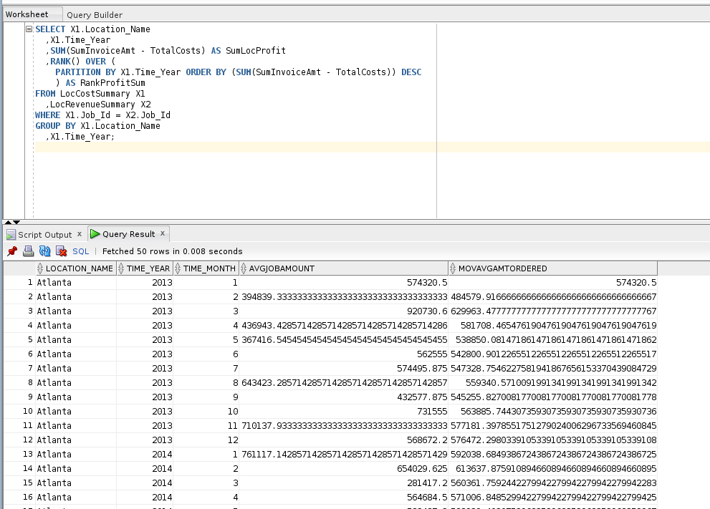

**Analytic query 4 (AQ4):**

AQ4 extends BQ2 and BQ3 with ranking of locations by annual profit margin. Ranking starts over for each contract year. Two SELECT statement solutions are shown. The first and simpler solution uses views containing SELECT statements for BQ2 and BQ3. The WHERE clause contains a join condition on Job_Id combining the views for BQ2 and BQ3. The second and more complex solution uses base queries for BQ2 and BQ3 in the FROM clause instead of views. The WHERE clause contains a join condition on Job_Id combining the nested queries for BQ2 and BQ3. In both solutions, annual profit margin is computed AS SUM( SumInvoiceAmt – TotalCosts ) / SUM (SumInvoiceAmt).

-- Rank locations by descending annual profit margin

-- Extends BQ2 and BQ3

-- Using views for location revenue and location cost summaries

|  |
| --- |
| SELECT X1.Location_Name  ,X1.Time_Year  ,SUM(SumInvoiceAmt - TotalCosts) / SUM(SumInvoiceAmt) AS ProfitMargin  ,RANK() OVER (  PARTITION BY X1.Time_Year ORDER BY (SUM(SumInvoiceAmt - TotalCosts) / SUM(SumInvoiceAmt)) DESC  ) AS RankProfitMargin  FROM LocCostSummary X1  ,LocRevenueSummary X2  WHERE X1.Job_Id = X2.Job_Id  GROUP BY X1.Location_Name  ,X1.Time_Year;  -- Base queries for location revenue and location cost summaries  SELECT X1.Location_Name  ,X1.Time_Year  ,SUM(SumInvoiceAmt - TotalCosts) / SUM(SumInvoiceAmt) AS ProfitMargin  ,RANK() OVER (  PARTITION BY X1.Time_Year ORDER BY (SUM(SumInvoiceAmt - TotalCosts) / SUM(SumInvoiceAmt)) DESC  ) AS RankProfitMargin  FROM (  SELECT W_Sub_Job_F.Job_Id  ,W_Location_D.LOCATION_ID  ,W_LOCATION_D.LOCATION_NAME  ,W_TIME_D.TIME_YEAR  ,W_TIME_D.TIME_MONTH  ,SUM(Invoice_Quantity) AS SumInvoiceQty  ,SUM(Invoice_Amount) AS SumInvoiceAmt  FROM W_Job_Shipment_F  ,W_Sub_Job_F  ,W_Location_D  ,W_Time_D  ,_InvoiceLine_F  ,W_Job_F  WHERE W_Sub_Job_F.Sub_Job_Id = W_Job_Shipment_F.Sub_Job_Id  AND W_Job_Shipment_F.Invoice_Id = W_InvoiceLine_F.Invoice_Id  AND W_Time_D.Time_Id = Contract_Date  AND W_Location_D.Location_Id = W_InvoiceLine_F.Location_Id  AND W_Job_F.Job_Id = W_Sub_Job_F.Job_Id  GROUP BY W_Sub_Job_F.Job_Id  ,W_Location_D.LOCATION_ID  ,W_LOCATION_D.LOCATION_NAME  ,W_TIME_D.TIME_YEAR  ,W_TIME_D.TIME_MONTH  ) X1  ,(  SELECT W_Sub_Job_F.Job_Id  ,W_Location_D.LOCATION_ID  ,W_LOCATION_D.LOCATION_NAME  ,W_TIME_D.TIME_YEAR  ,W_TIME_D.TIME_MONTH  ,SUM(Cost_Labor) AS SumLaborCosts  ,SUM(Cost_Material) AS SumMaterialCosts  ,SUM(Cost_Overhead) AS SumOvrhdCosts  ,SUM(Machine_Hours * Rate_Per_Hour) AS SumMachineCosts  ,SUM(Quantity_Produced) AS SumQtyProduced  ,SUM(Cost_Labor + Cost_Material + Cost_Overhead + (Machine_Hours * Rate_Per_Hour)) AS TotalCosts  FROM W_Job_F  ,W_Sub_Job_F  ,W_Location_D  ,W_Time_D  ,W_Machine_Type_D  WHERE W_Job_F.Location_Id = W_Location_D.Location_Id  AND W_Sub_Job_F.Machine_Type_Id = W_Machine_Type_D.Machine_Type_Id  AND W_Time_D.Time_Id = Contract_Date  AND W_Job_F.Job_Id = W_Sub_Job_F.Job_Id  GROUP BY W_Sub_Job_F.Job_Id  ,W_Location_D.LOCATION_ID  ,W_LOCATION_D.LOCATION_NAME  ,W_TIME_D.TIME_YEAR  ,W_TIME_D.TIME_MONTH  ) X2  WHERE X1.Job_Id = X2.Job_Id  GROUP BY X1.Location_Name  ,X1.Time_Year; |

**Screenshot:**

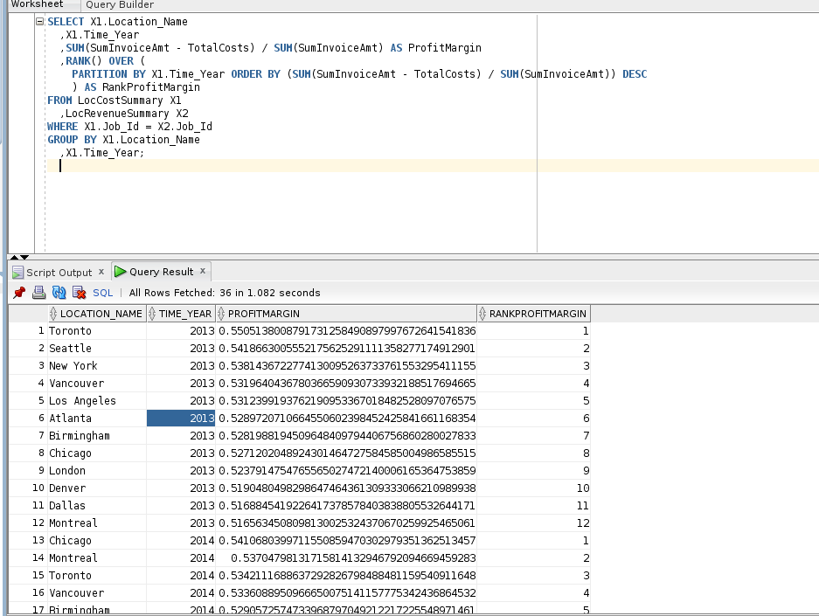

**Analytic query 5 (AQ5):**

AQ5 extends BQ2 and BQ3 with percent ranking of jobs by profit margins. A single percent ranking is computed without partitioning. Two SELECT statement solutions are shown. The first and simpler solution uses views containing SELECT statements for BQ2 and BQ3. The WHERE clause contains a join condition on Job_Id combining the views for BQ2 and BQ3. The second and more complex solution uses base queries for BQ2 and BQ3 in the FROM clause instead of views. The WHERE clause contains a join condition on Job_Id combining the nested queries for BQ2 and BQ3. In both solutions, profit margin is computed AS ( SumInvoiceAmt – TotalCosts ) / SumInvoiceAmt.

-- Percent rank jobs by annual profit margin

-- Extends BQ2 and BQ3

-- Using views for location revenue and location cost summaries

|  |
| --- |
| SELECT X1.Job_Id  ,X1.Location_Name  ,X1.Time_Year  ,X1.Time_Year  ,(SumInvoiceAmt - TotalCosts) / SumInvoiceAmt AS ProfitMargin  ,PERCENT_RANK() OVER (  ORDER BY ((SumInvoiceAmt - TotalCosts) / SumInvoiceAmt)  ) AS PercentRankProfitMargin  FROM LocCostSummary X1  ,LocRevenueSummary X2  WHERE X1.Job_Id = X2.Job_Id;  -- Using base queries for location revenue and location cost summaries  SELECT X1.Job_Id  ,X1.Location_Name  ,X1.Time_Year  ,X1.Time_Month  ,(SumInvoiceAmt - TotalCosts) / SumInvoiceAmt AS ProfitMargin  ,PERCENT_RANK() OVER (  ORDER BY ((SumInvoiceAmt - TotalCosts) / SumInvoiceAmt)  ) AS PercentRankProfitMargin  FROM (  SELECT W_Sub_Job_F.Job_Id  ,W_Location_D.LOCATION_ID  ,W_LOCATION_D.LOCATION_NAME  ,W_TIME_D.TIME_YEAR  ,W_TIME_D.TIME_MONTH  ,SUM(Invoice_Quantity) AS SumInvoiceQty  ,SUM(Invoice_Amount) AS SumInvoiceAmt  FROM W_Job_Shipment_F  ,W_Sub_Job_F  ,W_Location_D  ,W_Time_D  ,W_InvoiceLine_F  ,W_Job_F  WHERE W_Sub_Job_F.Sub_Job_Id = W_Job_Shipment_F.Sub_Job_Id  AND W_Job_Shipment_F.Invoice_Id = W_InvoiceLine_F.Invoice_Id  AND W_Time_D.Time_Id = Contract_Date  AND W_Location_D.Location_Id = W_InvoiceLine_F.Location_Id  AND W_Job_F.Job_Id = W_Sub_Job_F.Job_Id  GROUP BY W_Sub_Job_F.Job_Id  ,W_Location_D.LOCATION_ID  ,W_LOCATION_D.LOCATION_NAME  ,W_TIME_D.TIME_YEAR  ,W_TIME_D.TIME_MONTH  ) X1  ,(  SELECT W_Sub_Job_F.Job_Id  ,W_Location_D.LOCATION_ID  ,W_LOCATION_D.LOCATION_NAME  ,W_TIME_D.TIME_YEAR  ,W_TIME_D.TIME_MONTH  ,SUM(Cost_Labor) AS SumLaborCosts  ,SUM(Cost_Material) AS SumMaterialCosts  ,SUM(Cost_Overhead) AS SumOvrhdCosts  ,SUM(Machine_Hours * Rate_Per_Hour) AS SumMachineCosts  ,SUM(Quantity_Produced) AS SumQtyProduced  ,SUM(Cost_Labor + Cost_Material + Cost_Overhead + (Machine_Hours * Rate_Per_Hour)) AS TotalCosts  FROM W_Job_F  ,W_Sub_Job_F  ,W_Location_D  ,W_Time_D  ,W_Machine_Type_D  WHERE W_Job_F.Location_Id = W_Location_D.Location_Id  AND W_Sub_Job_F.Machine_Type_Id = W_Machine_Type_D.Machine_Type_Id  AND W_Time_D.Time_Id = Contract_Date  AND W_Job_F.Job_Id = W_Sub_Job_F.Job_Id  GROUP BY W_Sub_Job_F.Job_Id  ,W_Location_D.LOCATION_ID  ,W_LOCATION_D.LOCATION_NAME  ,W_TIME_D.TIME_YEAR  ,W_TIME_D.TIME_MONTH  ) X2  WHERE X1.Job_Id = X2.Job_Id; |

**Screenshot:**

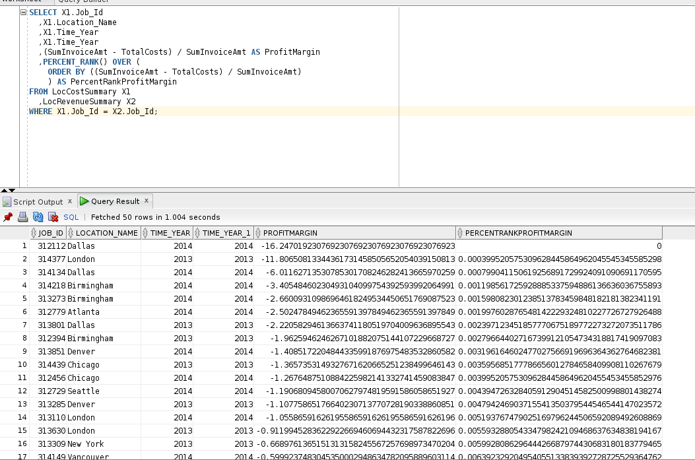

**Analytic query 6 (AQ6):**

AQ6 extends AQ5 directly (and BQ2 and BQ3 indirectly) with the top 5% of job profit margins. The WHERE clause in the outer query contains a condition on the percent rank computed in the nested query in the FROM clause. AQ5 is used in the FROM clause.

-- Top performers of percent rank of job profit margins

-- Using SELECT statement of AQ5 in the FROM clause

|  |
| --- |
| SELECT Job_Id  ,Location_Name  ,Time_Year  ,Time_Month  ,ProfitMargin  ,PercentRankProfitMargin  FROM (  SELECT X1.Job_Id  ,X1.Location_Name  ,X1.Time_Year  ,X1.Time_Month  ,(SumInvoiceAmt - TotalCosts) / SumInvoiceAmt AS ProfitMargin  ,PERCENT_RANK() OVER (  ORDER BY ((SumInvoiceAmt - TotalCosts) / SumInvoiceAmt)  ) AS PercentRankProfitMargin  FROM LocCostSummary X1  ,LocRevenueSummary X2  WHERE X1.Job_Id = X2.Job_Id  )  WHERE PercentRankProfitMargin > 0.95; |

**Screenshot:**

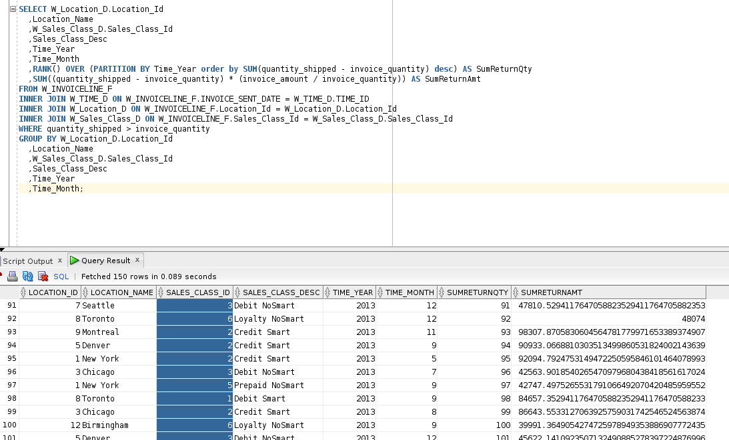

**Analytic query 7 (AQ7):**

AQ6 extends BQ4 with ranking of sales classes by the sum of the return quantity. The ranking restarts on every year. The WHERE clause contains a condition that quantity shipped is greater than invoice quantity. This condition comes from the base query, BQ4.

-- Rank sales class by sum of return quantities

-- Partition rank by year

|  |
| --- |
| SELECT Sales_Class_Desc  ,Time_Year  ,SUM(quantity_shipped - invoice_quantity) AS ReturnSum  ,RANK() OVER (  PARTITION BY Time_Year ORDER BY SUM(quantity_shipped - invoice_quantity) DESC  ) AS RankReturnSum  FROM W_INVOICELINE_F  INNER JOIN W_TIME_D ON W_INVOICELINE_F.INVOICE_SENT_DATE = W_TIME_D.TIME_ID  INNER JOIN W_Sales_Class_D ON W_INVOICELINE_F.Sales_Class_Id = W_Sales_Class_D.Sales_Class_Id  WHERE quantity_shipped > invoice_quantity  GROUP BY Sales_Class_Desc  ,Time_Year; |

**Screenshot:**

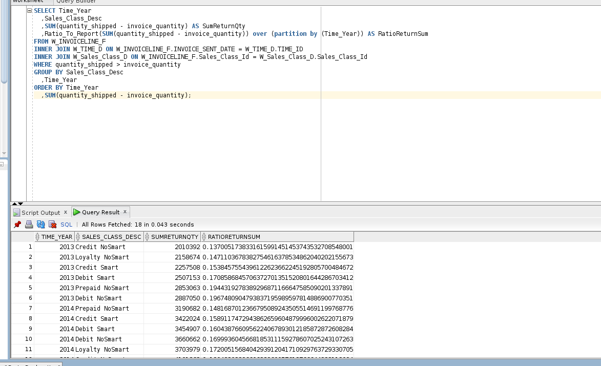

**Analytic query 8 (AQ8):**

AQ8 extends BQ4 with ratio to report of sales classes by the sum of the return quantity. The ranking restarts on every year. The WHERE clause contains a condition that quantity shipped is greater than invoice quantity. This condition comes from the base query, BQ4. The ORDER BY clause ensures a convenient ordering by year and return quantity.

-- Ratio to report for sales classes on sum of return quantity

-- Partition ratio to report by year

|  |
| --- |
| SELECT Time_Year  ,Sales_Class_Desc  ,SUM(quantity_shipped - invoice_quantity) AS SumReturnQty  ,Ratio_To_Report(SUM(quantity_shipped - invoice_quantity)) OVER (PARTITION BY Time_Year) AS RatioReturnSum  FROM W_INVOICELINE_F  INNER JOIN W_TIME_D ON W_INVOICELINE_F.INVOICE_SENT_DATE = W_TIME_D.TIME_ID  INNER JOIN W_Sales_Class_D ON W_INVOICELINE_F.Sales_Class_Id = W_Sales_Class_D.Sales_Class_Id  WHERE quantity_shipped > invoice_quantity  GROUP BY Sales_Class_Desc  ,Time_Year  ORDER BY Time_Year  ,SUM(quantity_shipped - invoice_quantity); |

**Screenshot:**

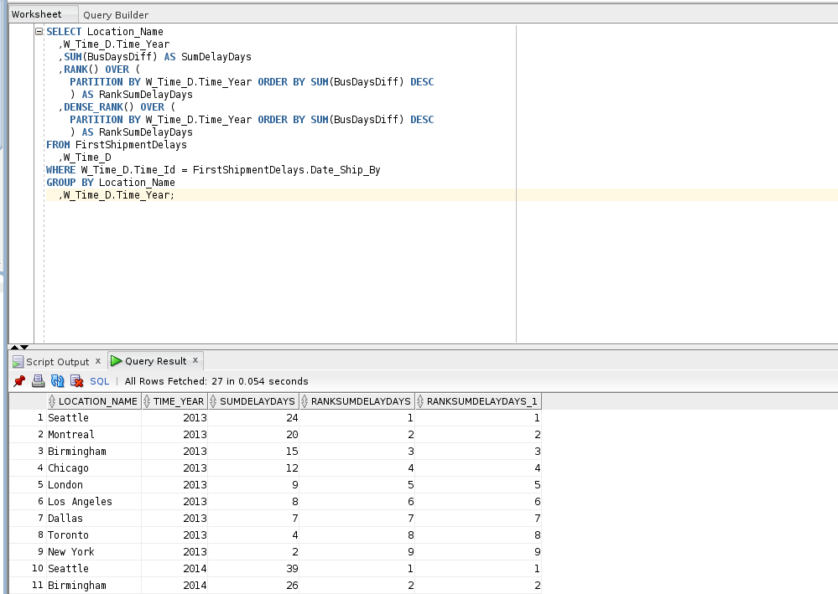

**Analytic query 9 (AQ9):**

AQ9 extends BQ6 with ranking of locations on the sum of the business days delayed for locations. BQ5 involves delays on the first shipment date compared to the date shipped by in the job. Both ranking functions should be used. The ranking restarts on each year of the date promised. The FROM clause combines the view for BQ6 (LastShipmentDelays) and time dimension table. The WHERE clause contains a join condition on Time_Id of the time dimension table with the Date_Ship_By of the view.

-- Rank locations by sum of business days delayed

-- Partition ranking by year of shipped by date

-- Use both rank and dense_rank functions

-- Uses FirstShipmentDelays view (based on BQ6)

|  |
| --- |
| SELECT Location_Name  ,W_Time_D.Time_Year  ,SUM(BusDaysDiff) AS SumDelayDays  ,RANK() OVER (  PARTITION BY W_Time_D.Time_Year ORDER BY SUM(BusDaysDiff) DESC  ) AS RankSumDelayDays  ,DENSE_RANK() OVER (  PARTITION BY W_Time_D.Time_Year ORDER BY SUM(BusDaysDiff) DESC  ) AS RankSumDelayDays  FROM FirstShipmentDelays  ,W_Time_D  WHERE W_Time_D.Time_Id = FirstShipmentDelays.Date_Ship_By  GROUP BY Location_Name  ,W_Time_D.Time_Year; |

**Screenshot:**

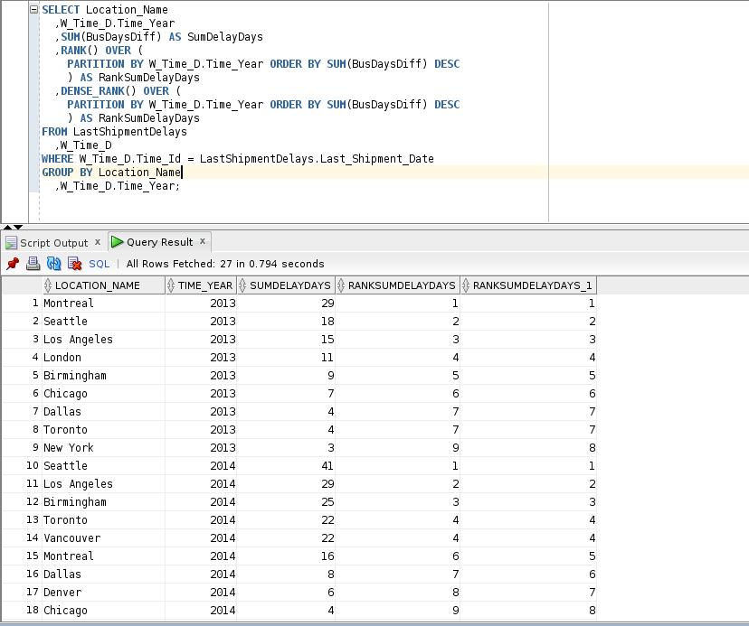

**Analytic query 10 (AQ10):**

AQ10 extends BQ5 with ranking of locations on the delay rate. BQ5 involves delays on the last shipment date compared to the date promised in the job. The ranking restarts on each year of the date promised. The FROM clause combines the view for BQ5 (LastShipmentDelays) and the time dimension table. The WHERE clause contains a join condition on Time_Id of the time dimension table with the Date_Promised of the view.

-- Rank locations by delay rate for the contract promised date

-- Partition ranking by year of date promised

-- Delay rate calculated as SUM(Quantity_Ordered - SumDelayShipQty) /

-- SUM(Quantity_Ordered)

-- Uses LastShipmentDelays view (based on BQ5)

|  |
| --- |
| SELECT Location_Name  ,W_Time_D.Time_Year  ,COUNT(*) AS NumJobs  ,SUM(BusDaysDiff) AS SumDelayDays  ,SUM(Quantity_Ordered - SumDelayShipQty) / SUM(Quantity_Ordered) AS PromisedDelayRate  ,RANK() OVER (  PARTITION BY W_Time_D.Time_Year ORDER BY SUM(Quantity_Ordered - SumDelayShipQty) / SUM(Quantity_Ordered) DESC  ) AS RankDelayRate  FROM LastShipmentDelays  ,W_Time_D  WHERE W_Time_D.Time_Id = LastShipmentDelays.Date_Promised  GROUP BY Location_Name  ,W_Time_D.Time_Year; |